**ROAD ACCIDENT REPORT SQL QUERIES**

**CY Casualties**

select sum(number_of_casualties) as CY_Casualties

from road_accident

where year(accident_date)='2022'



**CY Accidents**

select count(distinct accident_index) as CY_Accidents

from road_accident

where year(accident_date)='2022'



**CY Fatal Casualties**

select sum(number_of_casualties) as CY_Fatal_Casualties

from road_accident

where year(accident_date)='2022' and accident_severity='Fatal'



**CY Serious Casualties**

select sum(number_of_casualties) as CY_Serios_Casualties

from road_accident

where year(accident_date)='2022' and accident_severity='Serious'



**CY Slight Casualties**

select sum(number_of_casualties) as CY_Slight_Casualties

from road_accident

where year(accident_date)='2022' and accident_severity='Slight'



**Casualties by Vehicles Type**

Select CASE

WHEN vehicle_type in ('Agricultural vehicle') THEN 'Agricultural'

WHEN vehicle_type in ('Car' , 'Taxi/Private hire car') THEN 'Cars'

WHEN vehicle_type in ('Motorcycle 125cc and under','Motorcycle 50cc and under','Motorcycle over 125cc and up to 500cc','Motorcycle over 500cc','Pedal cycle') THEN 'Bike'

WHEN vehicle_type in ('Bus or coach (17 or more pass seats)','Minibus (8 - 16 passenger seats)') THEN 'Bus'

WHEN vehicle_type in ('Goods 7.5 tonnes mgw and over','Goods over 3.5t. and under 7.5t','Van / Goods 3.5 tonnes mgw or under') THEN 'Van'

ELSE 'Other'

end as vehicle_group,

sum(number_of_casualties)as CY_Casualtoies

from road_accident

where year (accident_date)='2022'

group by

CASE

WHEN vehicle_type in ('Agricultural vehicle') THEN 'Agricultural'

WHEN vehicle_type in ('Car' , 'Taxi/Private hire car') THEN 'Cars'

WHEN vehicle_type in ('Motorcycle 125cc and under','Motorcycle 50cc and under','Motorcycle over 125cc and up to 500cc','Motorcycle over 500cc','Pedal cycle') THEN 'Bike'

WHEN vehicle_type in ('Bus or coach (17 or more pass seats)','Minibus (8 - 16 passenger seats)') THEN 'Bus'

WHEN vehicle_type in ('Goods 7.5 tonnes mgw and over','Goods over 3.5t. and under 7.5t','Van / Goods 3.5 tonnes mgw or under') THEN 'Van'

ELSE 'Other'

end

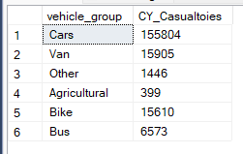

**CY Casualties vs PY Casualties by Month Trend**

select DATENAME(month,accident_date)as Month_name,sum (number_of_casualties) as CY_Casualties

from road_accident

where YEAR(accident_date)='2021'

group by datename(MONTH, accident_date)

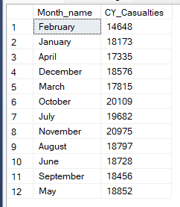

**CY Casualties by Road Type**

select road_type ,sum(number_of_casualties) as CY_Casualties

from road_accident

where year(accident_date)='2022'

group by road_type

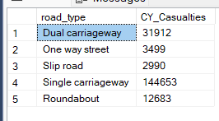

**Casualties by Urban or Rural Area**

select urban_or_rural_area,sum(number_of_casualties) as Total_casualties ,cast(sum(number_of_casualties) as decimal(10,2)) * 100 /

(select cast(sum(number_of_casualties) as decimal(10,2)) from road_accident where YEAR(accident_date)='2022') as PCT

from road_accident

where YEAR(accident_date)='2022'

group by urban_or_rural_area

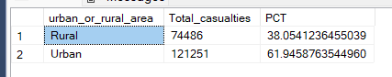

**Casualties by Light Conditions**

Select case when light_conditions In ('Daylight') then 'Day' when light_conditions In ('Darkness - lighting unknown','Darkness - lights unlit','Darkness - lights lit','Darkness - no lighting') then 'Night'

end as Light_condtion, cast(cast(sum(number_of_casualties) as decimal(10,2)) * 100 /

(select cast(sum(number_of_casualties) as decimal(10,2)) from road_accident where year(accident_date)='2022' ) as decimal(10,2)) as CY_Casualties_PCT

from road_accident where year(accident_date)='2022' group by case

when light_conditions In ('Daylight') then 'Day'

when light_conditions In ('Darkness - lighting unknown','Darkness - lights unlit','Darkness - lights lit','Darkness - no lighting') then 'Night end

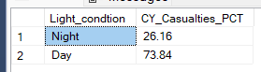

**Local Authority**

select top 10 local_authority ,sum(number_of_casualties) as Total_Casualties

from road_accident

group by local_authority

order by Total_Casualties

